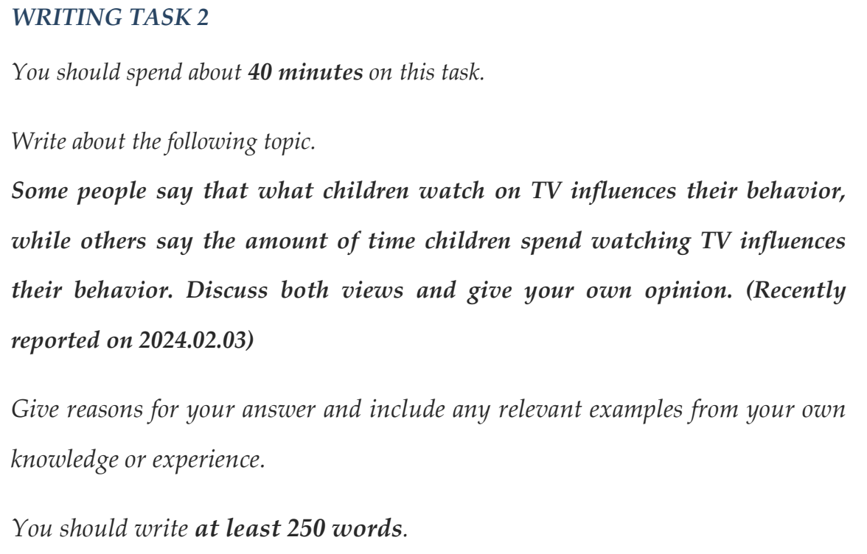
Time or content
Intro:content
BP1:
First of all,
news,educational videos nuture children’s ability of critical thinking

Improve a moral standard
Teaching them to act as a polite gentlemen.
A research from the beijin university show that 30% receive additional education
It means
Play a role in
BP2:
On the other hand ,it is not said that the content of TV is
BP3
Obviously,the figure of time spending on watching television can also influence

In contemporary society, what affect children’s behaviors has aroused a heated debate. Some individuals champion that it is the content shown by TV which play a significant role in adolescents’ behavior, while others hold a different opinion that the figure of time costing on TV is the main factor. Based on my observation, I predominantly inclined that the information provided by social media primarily has an important effect on kids’ style of dealing with things.
First of all, children can easily acquire special knowledge such as news by watching news programs on TV,which make them keep up with social trend and expand their horizons.Additionally,a research from Tsinghua University illustrates that it is not sufficient for young people to just receive education from school and parents-they need social education. As a consequence, various meaningful resources are beneficial to the development of children.
Nevertheless, there are potential issues that some programs show a number of horrible violence and insane opinions. And considered that most children lack of a ability to distinguish what is right from wrong things, they tend to emulate these behaviors from charming evil characters shown by television. It means hamful content could also have a negative influence on the young generation.
On the other hand, if young people lack of proper supervision by parents and schools, they will easily indugle in watching TV and neglect the time they spent on it, which are get in the way of their growth. According to an annual report from the Ministry of Education of China, 10% of people were addicted to watching TV for over 4 hours daily when they were kids. However, it could be dealed with through establishing related restrictions and laws by TV enterprises.
In a nutshell, I still hold the view that the content of social media has a fundamental impact on children, followed by the time children spend. But more importantly, how to keep the advantages and throw away disadvantages is what society really needs to think about.

